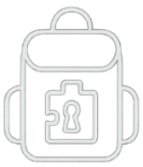
Welcome to
Escape Backpack!


Hiking Backpack

Enjoy the game!
For help, go to our website
https://sites.google.com/view/escapebackpack/home



Congratulations!
You completed the game!
Feel free to keep the plushy!
Let us know what you though of the game


